**DATA ANALYTICS WITH TABLEAU**

ASSIGNMENT-1

1. BAR CHART:-

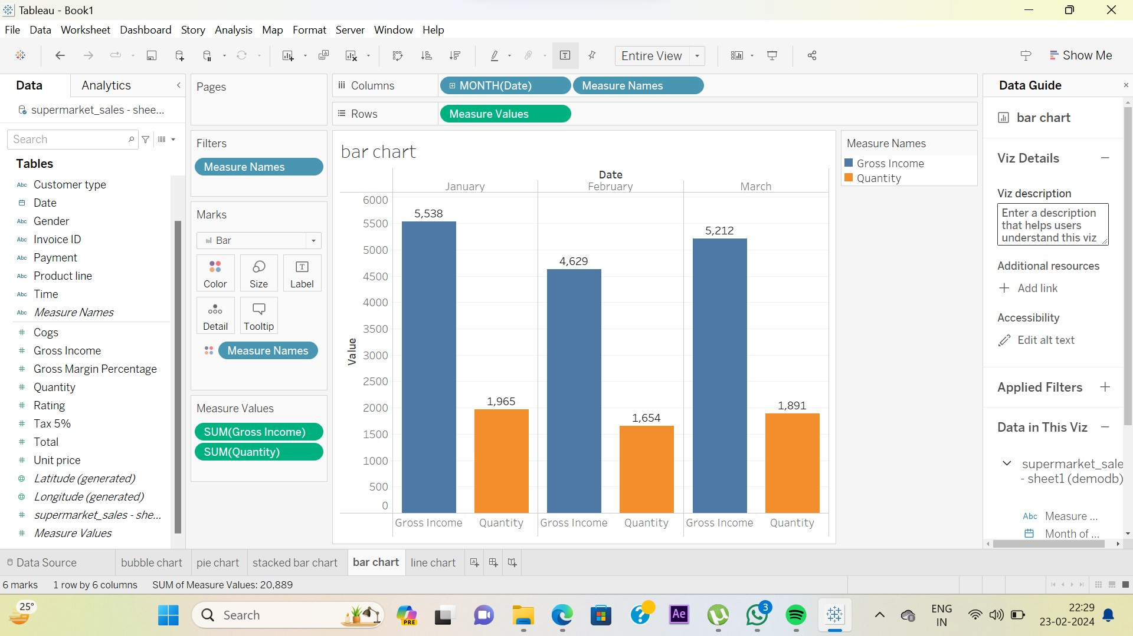

1. PIE CHART:-

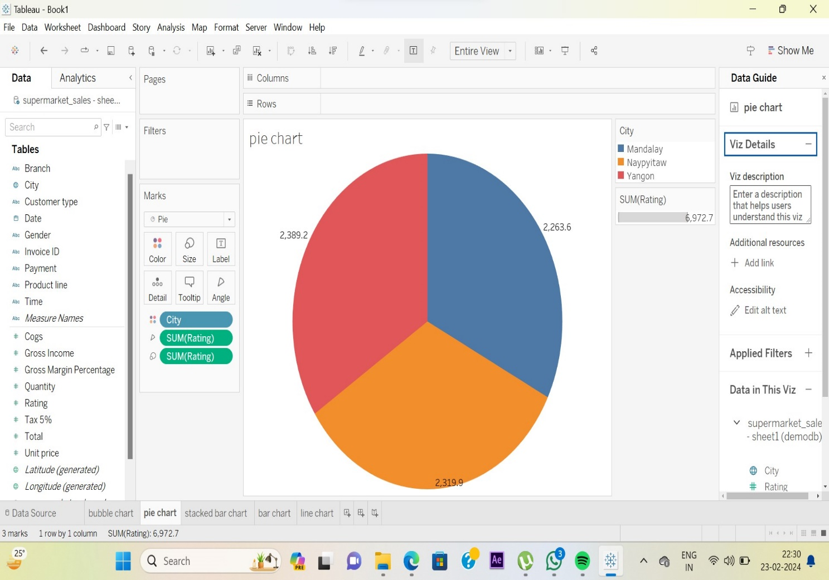

3.STACKED BAR CHART:-

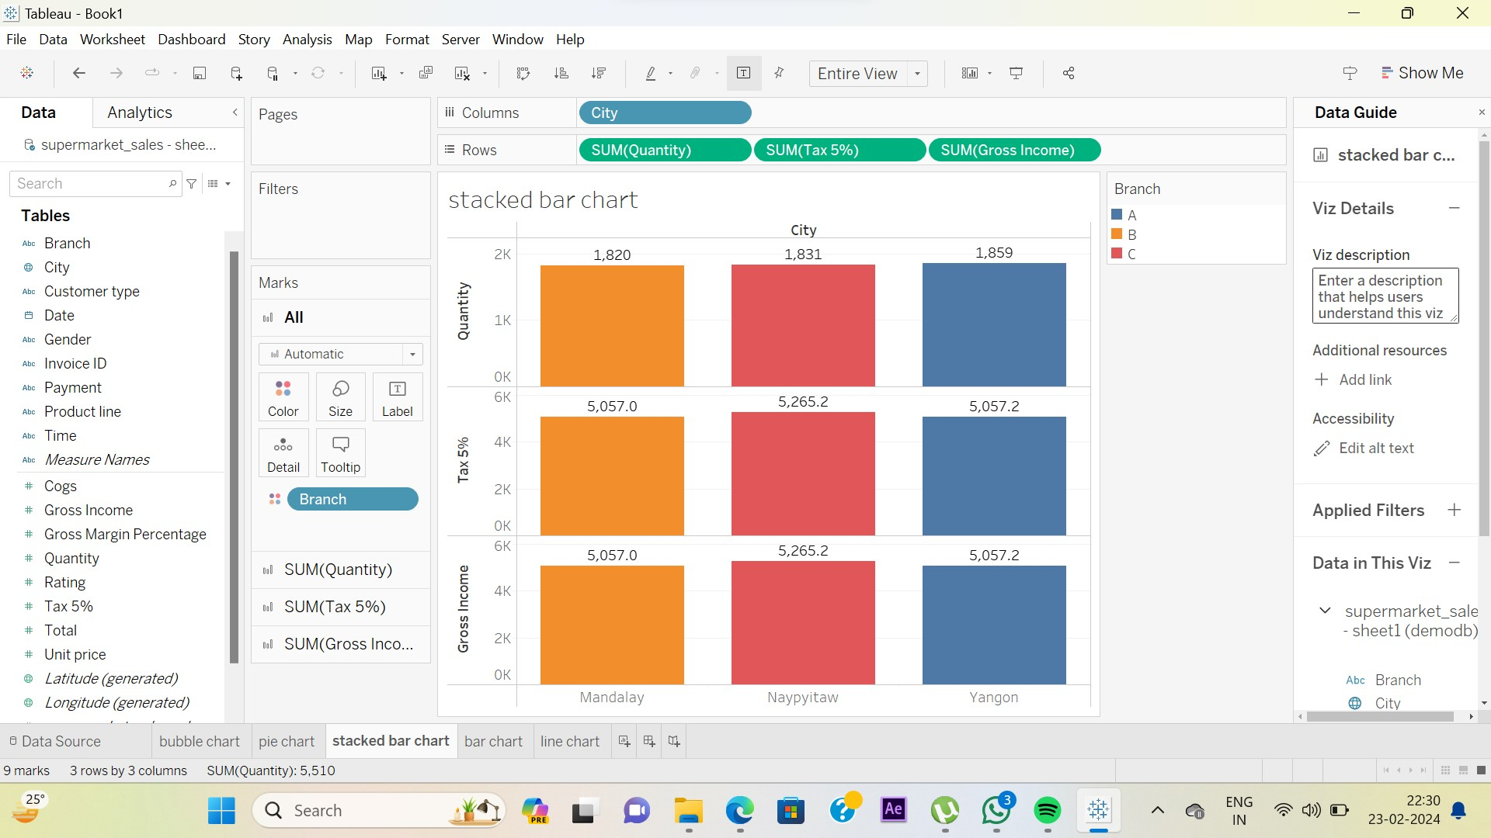

4. LINE CHART:-

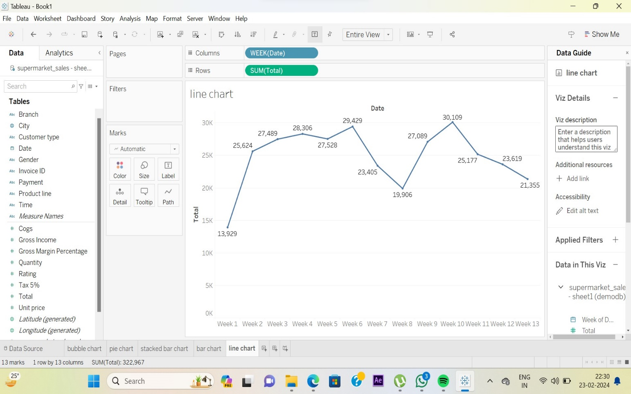

5. BUBBLE CHART:-

